Here Is the Title Which Begins Two Inches from the Top Margin:

Include a Subtitle If You Wish

by

Your Full Name

A Thesis Presented to the

FACULTY OF THE USC DORNSIFE COLLEGE OF LETTERS, ARTS AND SCIENCES

University of Southern California

In Partial Fulfillment of the

Requirements for the Degree

MASTER OF SCIENCE

(GEOGRAPHIC INFORMATION SCIENCE AND TECHNOLOGY)

Month 20XX

Copyright © 20XX Your Full Name

To a special person, my relative

# Acknowledgements

I am grateful to my mentor, Professor Smith, for the direction I needed and my other faculty who gave me assistance when I needed it. I would like to thank my employer, X Company, who allowed me to complete some of this work using my office computer. I am grateful for the data provided to me by Y Organization and the assistance in coding the analysis given my friend, George Day.

Table of Contents

List of Tables v

List of Figures vi

Abbreviations vii

Abstract viii

Chapter 1 Introduction (Heading 1 Style) 1

1.1. First Level Subhead (Heading 2 Style) 1

1.1.1. Second Level Subhead (Heading 3 Style) 2

Chapter 2 Related Work 6

References 7

Appendix A Title 8

# List of Tables

Table 1 A short title 5

Table 2 Summary of previous research including examples of work completed by other   
scholars working around the world 5

Table 3 A title which has been shortened from the actual caption 6

# List of Figures

Figure 1 Conceptual framework of the research 3

Figure 2 Workflow of the application 3

# Abbreviations

GIS Geographic information system

GISci Geographic information science

SSI Spatial Sciences Institute

USC University of Southern California

# Abstract

The Traveler tradition began in 1961 with Traveler the First. From 1961 to 1988, the equestrian mascots were selected, trained and ridden by Richard Saukko. After his death, the Saukko family continued the tradition of raising the famous Trojan horses until 2003, when equestrian manager Joanne Asman took over.

While abstracts are often formatted as a single paragraph, use additional paragraphs if it would make your text more easily read. Format the abstract similar to the main text. Do not include citations in the abstract since it will often be reproduced separately from the main document.

# Introduction (Heading 1 Style)

This paragraph gives an overview of the contents of this document. It provides motivation for the reader to continue reading. It also hints at the contents of this chapter. The text in the rest of this chapter is not true introductory material, it is simply included to illustrate formatting.

## First Level Subhead (Heading 2 Style)

Clustering methods were explored to show where armed-conflicts are concentrated and whether there is evidence of heavy clustering. In a heavily clustered environment, there is the potential to identify predictor variables that can be used to explain the highs and lows of the data. Six kernel density maps were created to produce rasterized surfaces indicating concentrations of the Lord’s Resistance Army (LRA) activity. Figure 1 reflects the kernel density of armed-conflicts in 2008.

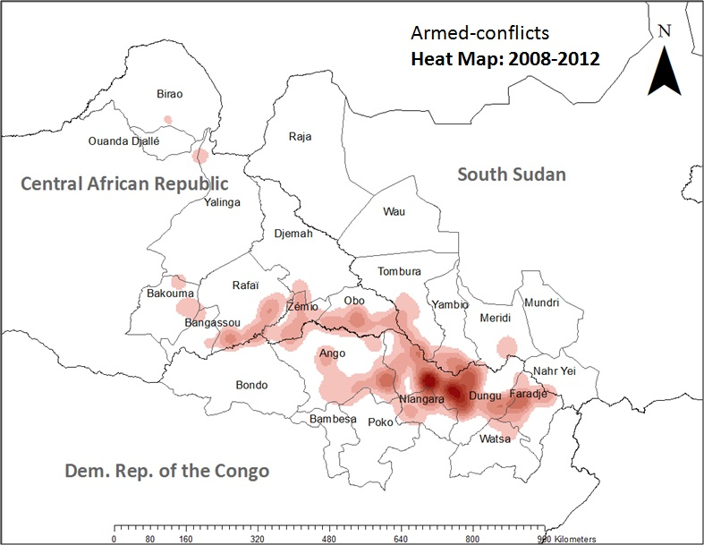

Figure . Heat map of armed conflicts in 2008

With conflict data spatially joined with the “Territories” feature class, Modelbuilder was used to generate 15 new territory feature classes as shown in Table 1.

Table 1. Armed conflicts by territory during 2008-2012, normalized by population

|  |  |  |  |  |  |  |
| --- | --- | --- | --- | --- | --- | --- |
| Country | Territory Name | 2008 | 2009 | 2010 | 2011 | 2012 |
| SSD | Raja | 0.00 | 0.04 | 0.00 | 0.07 | 0.00 |
|  | Wau | 0.00 | 0.00 | 0.01 | 0.00 | 0.00 |
|  | Nahr Yew | 0.01 | 0.01 | 0.00 | 0.00 | 0.00 |
|  | Meridi | 0.05 | 0.02 | 0.05 | 0.00 | 0.00 |
|  | Mundri | 0.00 | 0.02 | 0.00 | 0.00 | 0.00 |
|  | Tombura | 0.05 | 0.16 | 0.25 | 0.16 | 0.02 |
|  | Yambio | 0.02 | 0.02 | 0.10 | 0.10 | 0.00 |
| DRC | Ango | 0.00 | 4.15 | 3.69 | 2.54 | 1.84 |
|  | Bambesa | 0.00 | 0.00 | 0.00 | 0.06 | 0.00 |
|  | Bondo | 0.00 | 0.00 | 0.05 | 0.00 | 0.16 |
|  | Poko | 0.00 | 0.42 | 0.21 | 0.00 | 0.00 |
|  | Dungu | 1.39 | 3.08 | 8.64 | 5.02 | 4.34 |
|  | Faradje | 0.20 | 0.44 | 0.36 | 0.96 | 0.80 |
|  | Niangara | 0.07 | 1.22 | 1.86 | 0.36 | 0.43 |
|  | Watsa | 0.00 | 0.06 | 0.03 | 0.06 | 0.00 |
| CAR | Djemah | 0.00 | 2.18 | 0.00 | 0.00 | 0.00 |
|  | Obo | 0.08 | 1.05 | 0.31 | 0.39 | 0.14 |
|  | Zémio | 0.00 | 0.12 | 1.19 | 0.65 | 0.71 |
|  | Yalinga | 0.00 | 0.00 | 0.77 | 0.00 | 0.58 |
|  | Bakouma | 0.00 | 0.00 | 0.10 | 0.19 | 0.29 |
|  | Bangassou | 0.00 | 0.02 | 0.03 | 0.02 | 0.05 |
|  | Rafaï | 0.00 | 0.14 | 3.08 | 0.43 | 1.22 |
|  | Birao | 0.00 | 0.00 | 0.10 | 0.00 | 0.00 |

Source: Smith 1999

### Second Level Subhead (Heading 3 Style)

The process of calculating the annual rates of change by territory is illustrated in Figure 2. Included in this figure are the additional steps taken to compare changes between the sample group of territories and the control group as represented by the analysis.

After the rate changes were coded to each feature class, the territories were divided into two groups: the first group is the sample (*n*), which is composed of territories in which HF radios are located. The second group is the control (*m*), which is composed of territories without HF radios. HF radios were aggregated by territory and each territory was coded as either having or not having one or more HF radios. The mean rate of change for the control group was then subtracted from the mean rate of change for the sample group. Figure 4 is a conceptualization of this method, illustrating comparative changes between a sample group and a control group.

#### Third level subhead (Heading 4 style)

The comparative changes between the two groups are calculated using Equation 1, which is based on the Difference-in-Differences statistical method (Abadie 2005):

 (1)

Resulting values indicate how the rate of violence in territories with HF radios changed in comparison to territories without HF radios. The detailed flowchart for this approach is included in Figure 16. Due to the low *n*, the significance at local scale of the true Difference-in-Differences statistical analysis could not be established or validated. Therefore, the numerical results derived from this method are shown in chapter four and described qualitatively focusing on a comparative description of the results.

*Fourth level section.* Next, feature classes for the same category of violence were joined from one year to the next using a table join and a common ObjectID (Territory_Name); Armed-conflicts_2008 was joined with Armed-conflicts_2009, and Armed-conflicts_2009 was joined with Armed-conflicts_2010, etc. Figure 2 shows the location of these administrative areas by including a landscape formatted figure. This is continuing place holder text placeholder text

4

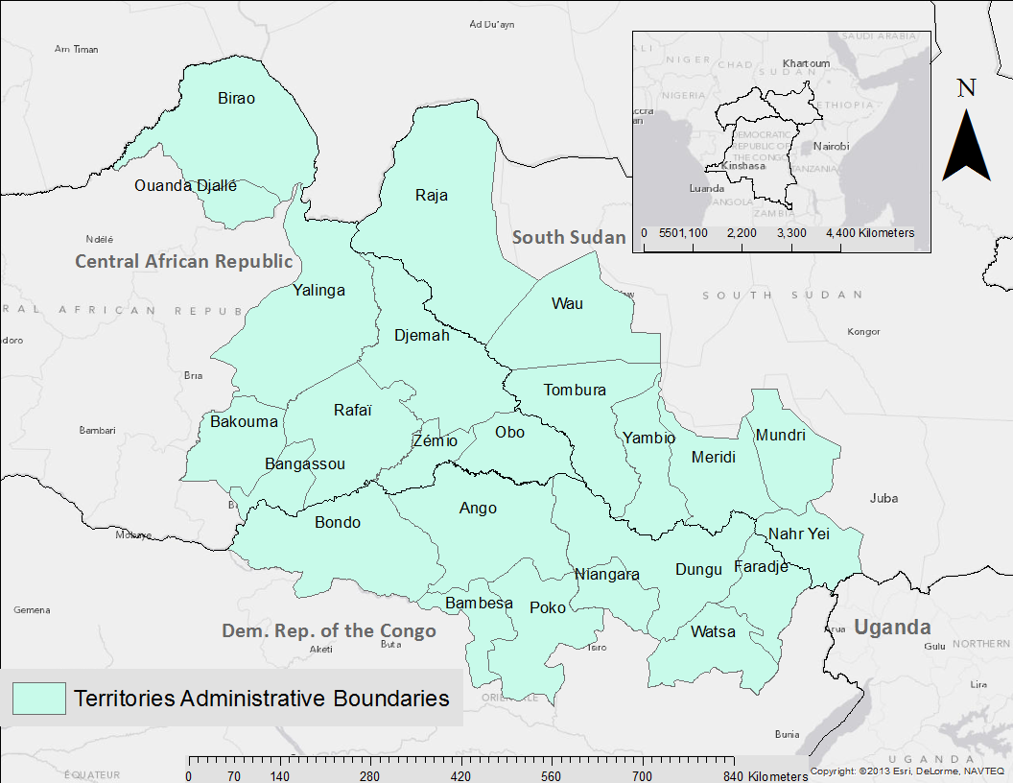

Figure . Administrative areas of the study area. Source: Jones 2010

this text continues after the landscaped page with the figure. Placeholder text placeholder text placeholder text placeholder text placeholder text.

# Related Work

The next chapter starts here. Note that the headings of chapters are not indented. Placeholder textplaceholder text placeholder text placeholder text.

References

Abadie, A. 2005. “Semiparametric Difference-in-differences Estimators.” *The Review of Economic Studies* 72: 1-18.

Wheeler, S.M. 2013. *Planning for Sustainability: Creating Livable, Equitable, and Ecological Communities*. New York, NY: Routledge.

# Appendix A Title

|  |  |  |  |
| --- | --- | --- | --- |
| 1. Data Collection | Reports are gathered from a variety of sources: | | |
|  |  | • HF radio towers in DRC and CAR | |
|  |  |  | o Civilians report activity to HF radio tower operators |
|  |  |  | o Over 30 HF radio operators call the Dungu hub twice daily to report armed-group |
|  |  |  | activity |
|  |  |  | o Activity is entered into a spreadsheet and then sent to data coders |
|  |  | • UN & NGO reports | |
|  |  | • News & media outlets | |
|  |  | • Civil society contacts in local communities | |
|  |  | • Field research conducted by Resolve and Invisible Children staff | |
| 2. Database Entry | Database entry: | | |
|  |  | • Reports are divided between a team of coders from both Invisible Children and Resolve. Coders determine if the source is reliable or unreliable (see section 4.2B of the codebook). Before an incident is reported, the coder reads through other incidents to check for duplicates. | |
|  |  | Verification ratings: | |
|  |  | • After an incident is categorized, each incident is given a verification rating (see section 4.2A of the codebook). | |
|  |  | • If a coder determines that an incident was potentially committed by the LRA, the incident is rated on the LRA Actor Verification Scale (see section 4.2C of the codebook). | |
| 3. Data Review |  | • A second data coder reviews each incident to catch human errors and duplicate reports (see section 4.1E). | |
|  |  | • IC and Resolve staff with field experience review sensitive incidents immediately and review all incidents every three months. Should these staff members feel an incident was misreported, the incident is corrected. External LRA and regional experts are consulted as necessary. | |
| 4. Data Mapping & Sharing |  | • After an incident is entered and approved to be mapped, it appears on the LRA Crisis Tracker website. | |
|  |  | • Data is regularly sent to UN agencies and humanitarian practitioners for comparison and collaboration. | |
| 5. Data Revamp |  | • As the database grows and policies are updated to reflect best practices, data coders revisit and “revamp” the data when needed. | |

Source: Abadie 2005